**ASSIGNMENT 7**

**AIM:-**

Design and Develop MongoDB Queries using CRUD operations.

**OBJECTIVE:-**

To perform Create, Insert, Update and Delete operations in no-sql database i.e. Mongo DB.

**OUTPUT:-**

**Insert Operation:**

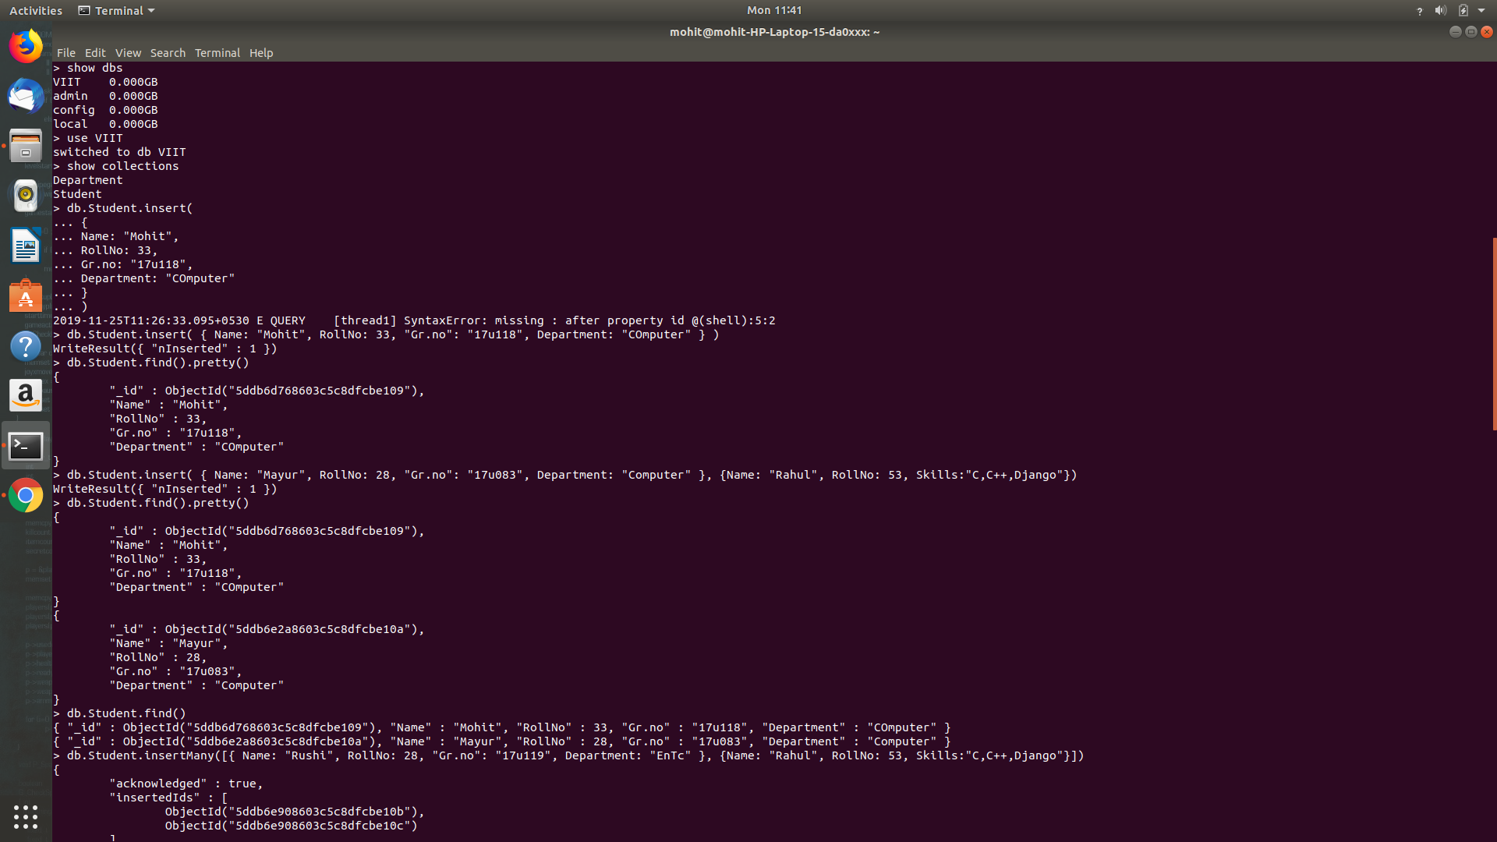

**­**

**Update and Delete:**

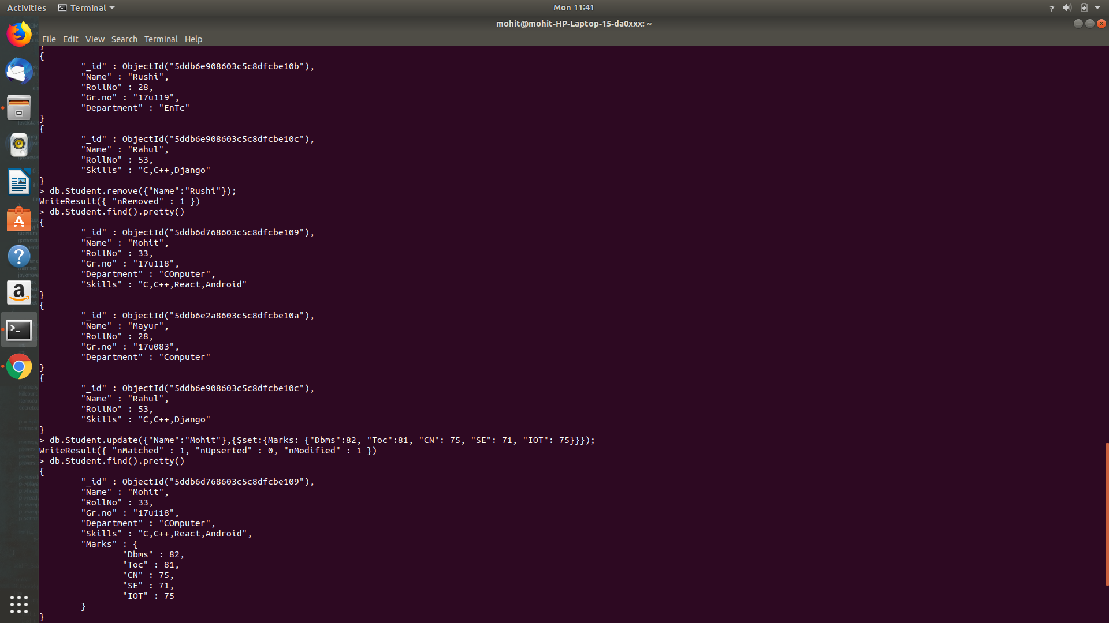

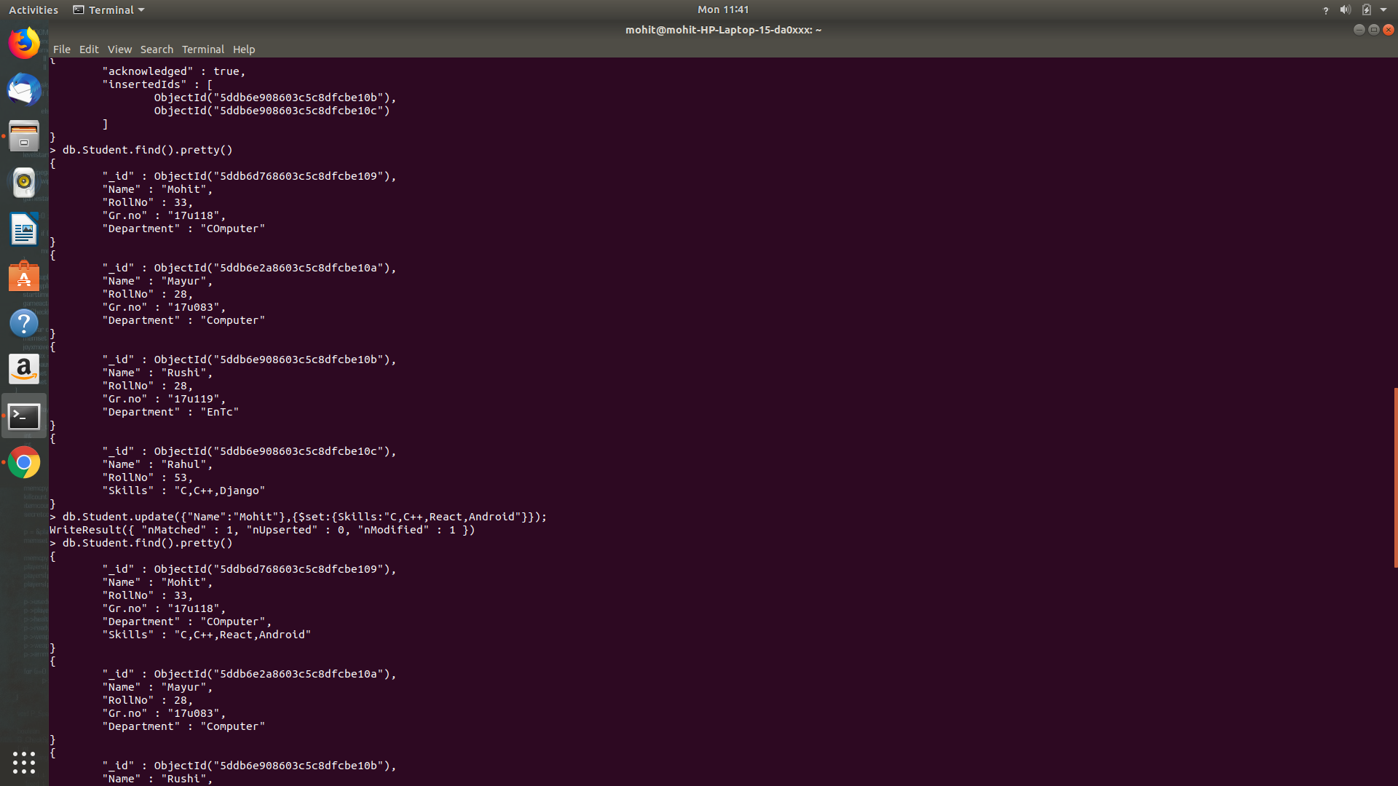**Show or Preety Operation:**